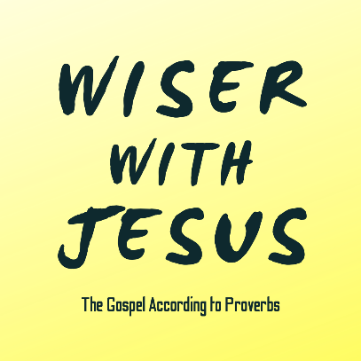
“The Sage”
Proverbs 10:8, 12:18, 13:14, 16:23, 23:15-19, 31:10-12, & James 3:13-18

Get Wisdom & Understanding!

The Wise Heart

The Heart of Christ for You

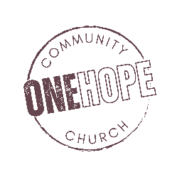
See also: Job 28, 1 Kings 4:29-34, Psalm 119:98, Proverbs 4:7, Matthew 12:42,
1 Corinthians 1:24, Ephesians 1:17, James 1:5
Discover More: considerjesus.au

