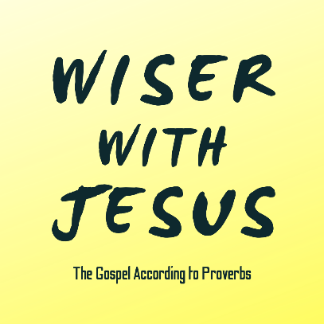
“The Simple”
Proverbs 1:1-7; 9:6, 14:15, 14:18, 22:3, 25:20 & Romans 16:17-18

The Ultimate Wisdom

Consider Your Naivety

The Heart of Christ for the Simple-Hearted



See also: Genesis 3:1-6, Psalm 116:6, Colossians 1:28, James 1:5.
Discover More: considerjesus.au

