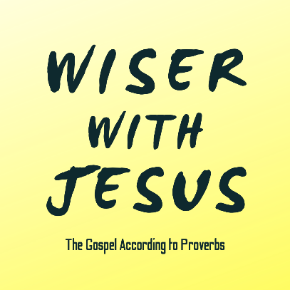
“The Mocker”
Proverbs 3:34; 9:6-12; 13:1; 21:24; Luke 23:33-39

Mockers, Scoffers, & Snarky Sneerers

Consider Your Scoffing Heart

The Heart of Christ for the Hardest Heart


See also: Psalm 1:1, Acts 6:7, Romans 16:17-18, Hebrews 12:3, 2 Peter 3:3, Jude 18
Discover More: considerjesus.au

