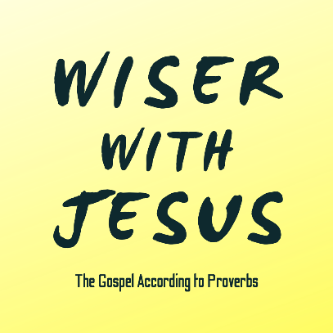
“The Fool”
Proverbs 1:20-23; 9:10; 13:20; 14:7-8; 17; 15:2, 18:2; 6, Luke 12:13-21

Relating to Fools

Consider Your Folly

The Heart of Christ for the ‘Fool-Hearted’


See also: 90+ Proverbs on fools, foolishness, & folly!
Romans 1:22, 1 Corinthians 4:10, Ephesians 5:15-21, Colossians 2:3, 1 Peter 5:6
& considerjesus.au

