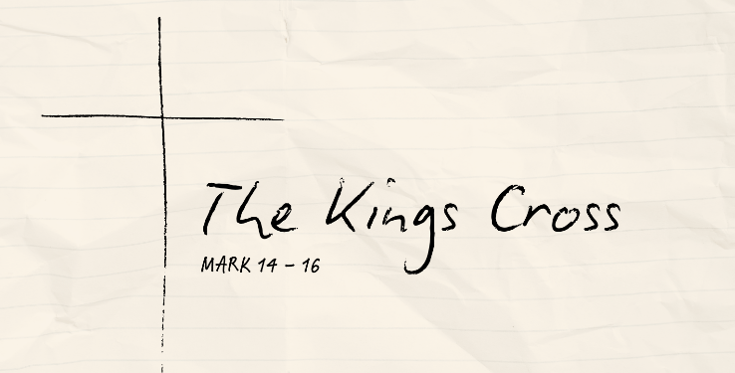
The King of Salvation
Mark 15:16-32 (CSB)

The Mocking of the King

The King’s Burden

Behold Your King!

See also: Genesis 50:20, Psalm 22:18, Isaiah 52:13-53:12, Mark 8:34; 10:45, Philippians 2:5-11, 1 Peter 2:22-24
Resources website: considerjesus.au

