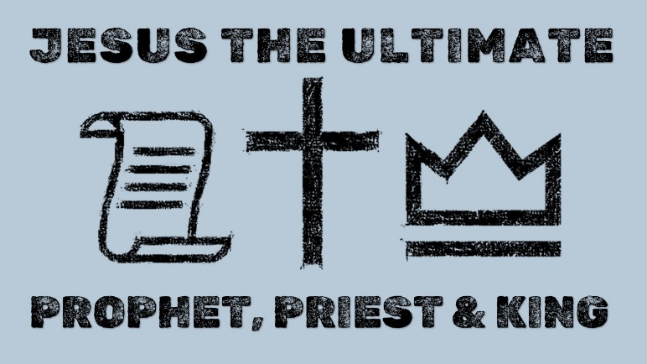
Matthew 21:1-16
Hebrews 1:1-3 & 4:14-16
(Christian Standard Bible)

The Ultimate Prophet

The Great High Priest

The Eternal King

See also: Deuteronomy 18:15-18, John 5:46, Romans 8:34, Colossians 3:16-17,
Hebrews 2:17; 1 Timothy 2:5-6 & find out more at considerjesus.au
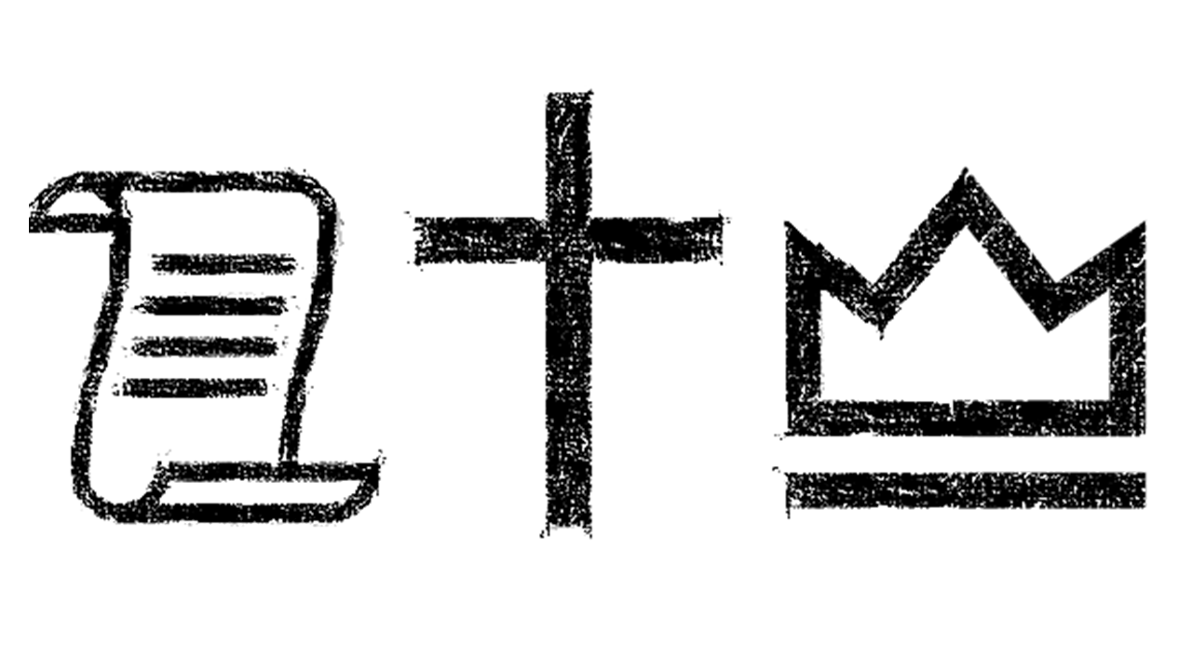
For PERSONAL reflection
- How does listening to Jesus’ word change my life today?
- Which of Jesus’ teachings do I find most uncomfortable or difficult to follow?
- If I truly believe Jesus is praying for me, how might that change the way I pray and approach my biggest fears?
- What does his final sacrifice mean for my relationship with God? How might this help me approach God with confidence and humility?
- Is Jesus king of my heart, my finances, my daily decisions, my relationships, and my work?
- When do I try to seek control instead of resting and yielding to his rule? What am I afraid will happen if I relinquish that control to him?
- How does seeing Jesus’ threefold office better shape my understanding of who he is?
- In what ways might followers of Jesus also be prophets, priests, and kings?

