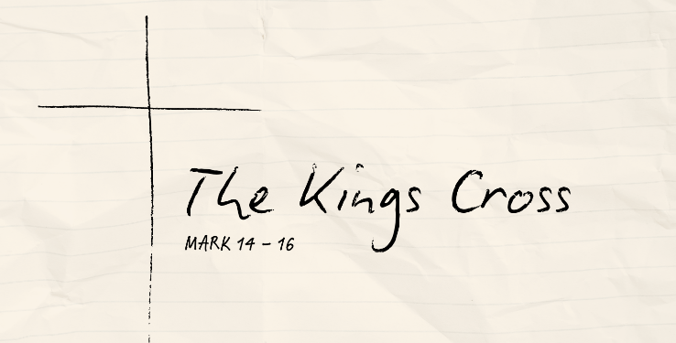
The Rescue to Remember
Mark 14:12-31 (CSB)

The Saviour’s Sovereignty

The Disciples’ Denials

The Lord’s Supper

See also: Psalm 3:8, Jonah 2:9, Mark 8:31-32, Matthew 28:18, John 13:1-30, 1 Corinthians 11:17-34,
Colossians 1:19-20 Hebrews 1:3 Resources website: considerjesus.au

