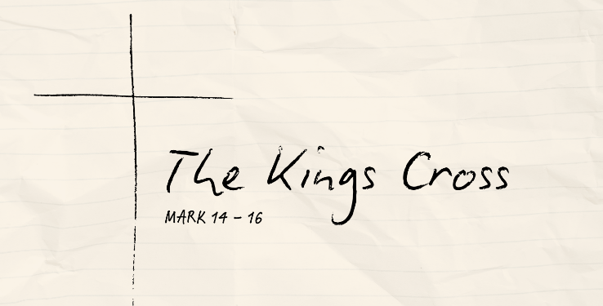
The Great Exchange
Mark 15:1-15 (CSB)

Prosecution of the Innocent

Freedom for the Guilty

What’s Your Verdict?

See also: Isaiah 53:7, Acts 8:30—35, 1 Corinthians 2:8, 2 Corinthians 5:21, Galatians 3:13, 1 Peter 2:22-24, 1 John 1:7-9
Resources website: considerjesus.au

