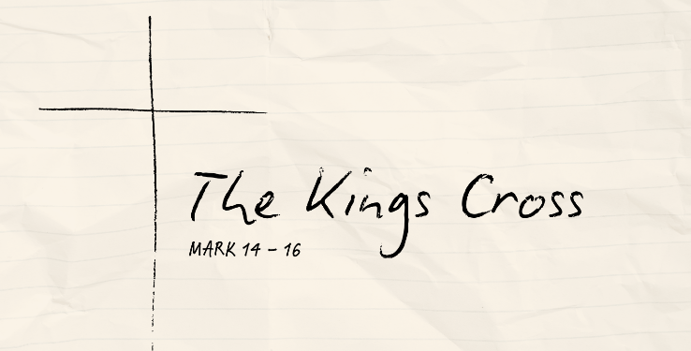
Bearing God‘s Wrath
Mark 14:12-31 (CSB)

The Son’s Agony

The Disciples’ Weakness

The Betrayer’s Kiss

See also: Psalm 75, Isaiah 53:3-10, Matthew 6:10, Romans 5:9; 8:1, 1 Thessalonians 1:10; 5:9, 1 John 4:9-10
Resources website: considerjesus.au

