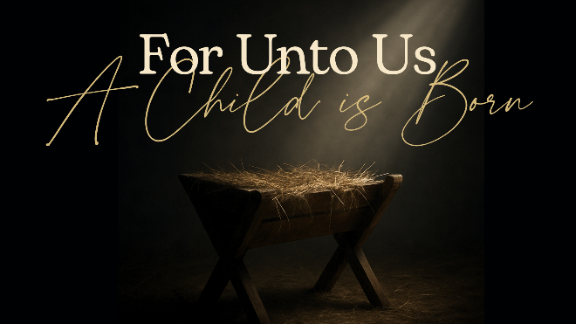
Mighty God
Matthew 8: 23-27, Matthew 26: 52-54

- Mighty in Creation

- Mighty in Salvation

- Mighty in Power

See also: Genesis 1:1-3, John 1:1-3, Isaiah 17:12, Exodus 14:21, 2 Kings 19:35
Find more at considerjesus.au

