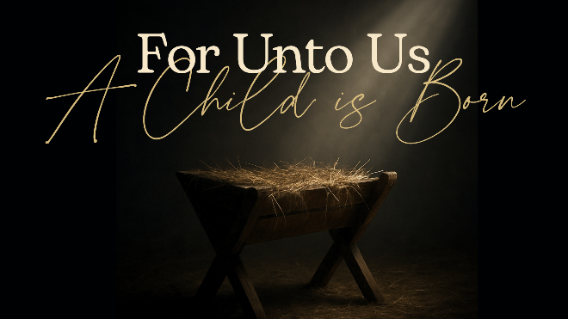
Everlasting Father
Psalm 103, Isaiah 9:6

- The Infinite Born an Infant

- His Fatherly Compassion

- Perpetual Provider & Protector

See also: Psalm 18:2, John 1:12-13; 17:1-5, 1 Corinthians 8:5-6, Hebrews 5:9; 13:8
Find more at considerjesus.au

