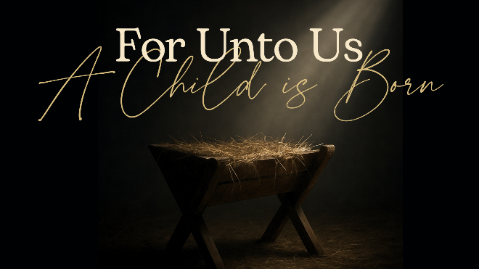
Wonderful Counsellor
Isaiah 9:6, Psalm 1 & Romans 11:33-36

- Good Counsel Matters

- Behold the Incomparable Christ

- Will You Heed His Word?

See also: Isaiah 8:19; 28:29, Psalm 1; 25:4-5, 139:6,
Matthew 7:24, Romans 11:33-35, 1 Corinthians 1:30.
Find more at considerjesus.au

