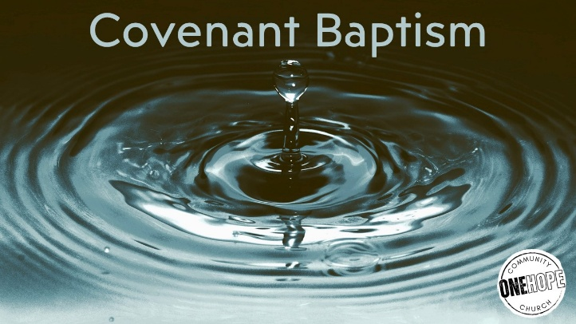

Acts 2:36-41 & 16:25-34 (CSB)

- Handle With Care

- The New Covenant Sign & Seal

- As for Me & My House…

See also: Genesis 17:9-14, Matthew 19:14; 28:19, Luke 3:1-3, Romans 6:3-4,
1 Corinthians 7:14, Colossians 2:11-14.

Visit considerjesus.au for more info, reading, and our confessional positions on baptism.

