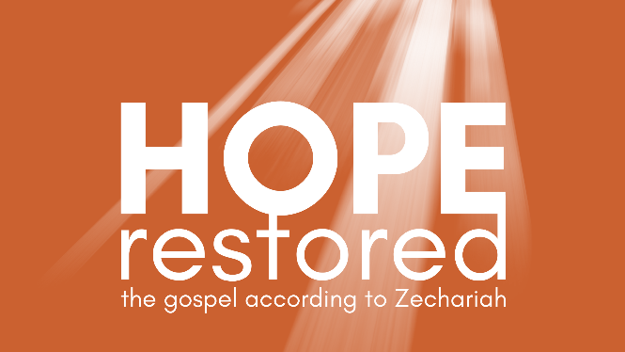
The Day of Salvation
Zechariah 12-14 (CSB)

- The Day God Was Pierced

- The Day of the LORD

- Hope Restored Today

See also: Isaiah 53:5, Luke 19:37-40, John 19:34-37, 2 Corinthians 5:21-6:2, Revelation 1:7
Discover more at considerjesus.au
