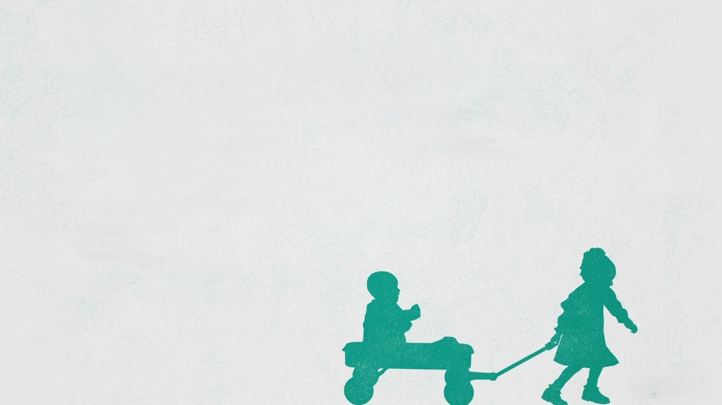
The Children of God
John 14:1-6 ; 1 John 2:28-3:3 (CSB)

The Way to the Father

The Father’s Love

The Privilege of Family

See also: Matthew 6:7-15, John 14:7-12, Romans 8:14-17, Ephesians 1:5; 2:18, 1 John 1:12.
Visit considerjesus.au to discover more.

