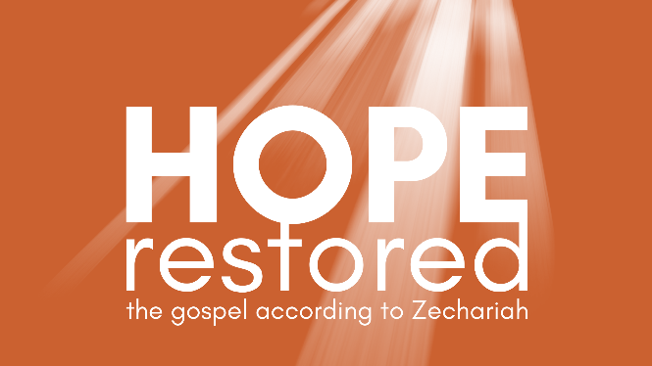
True Religion
Zechariah 7:1-8:23 (CSB)

- Get Real About Religion

- A Transformed Relationship

- Seek the LORD Today!

See also: Psalm 105:1-4, Matthew 6:16-18, Luke 18:9-14,
John 1:44-45, Acts 17:30-31, James 1:26-27
Discover more at considerjesus.au

