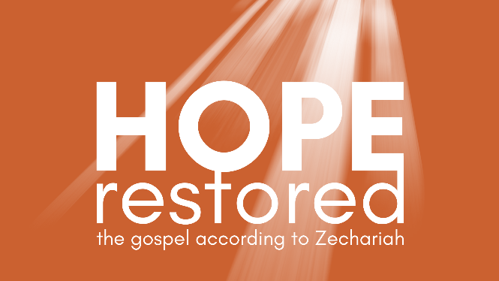
The Shepherd King
Zechariah 9:1 – 11:17 (CSB)

- The King Like No Other

- True & False Shepherds

- The Rejected Shepherd

See also: Psalm 23:1-4, Ezekiel 34, Matthew 21:1-11, John 10:11; 25-28, Ephesians 2:1-3.

Discover more at considerjesus.au

