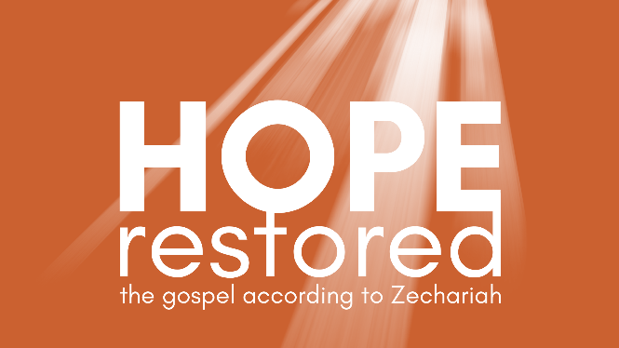
Sin Removed | Hope Restored
Zechariah 5:1-6:15 (CSB)

- Sin Removed

- Hope Restored

See also: Psalm 103:12, Jeremiah 33:15-16, Romans 3:23-24,
Hebrews 7, Revelation 6:1-8.
Discover more at considerjesus.au

