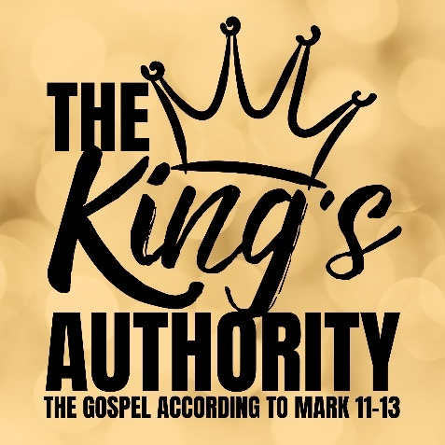
The King’s Return
Mark 13:1-37

- The End of the Temple

- The Return at the End

- Living in Light of the End

See also: Daniel 7; 9; 11, 1 Thess 4:13-5:11, 2 Peter 3:10, Revelation 20-22.

Discover more about Jesus: considerjesus.au

