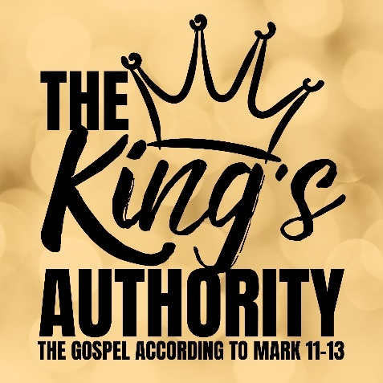
The King’s Verdict
Mark 12:38-44

- Beware of Phony Religion

- Observe True Devotion

- Behold the King’s Grace!

See also: Exodus 22:22-24, Matthew 23:1-39, 2 Corinthians 8:9,
Hebrews 13:14-16, James 3:1, 1 Timothy 6:17.

Discover more about Jesus: considerjesus.au

