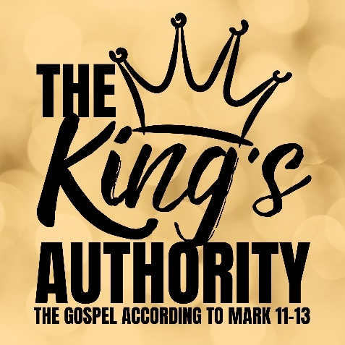
The King’s Commandments
Mark 12:28-34

- The One & Only God

2a. Loving God with Your All

2b. Loving Your Neighbour as Yourself

- God’s Kingdom & You!

See also: Deuteronomy 6:4-5, Isaiah 45:5, 1 John 3:1; 4:7-21, Matthew 5:43-45, Luke 10:29-37.

Discover more about Jesus: considerjesus.au

