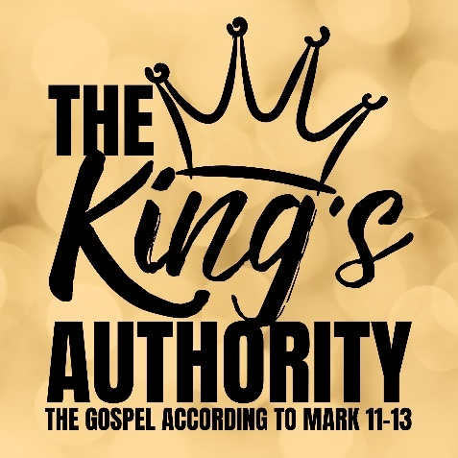
The King’s Absolute Authority
Mark 12:35-37

- Great David’s Greater Son

- King of Kings | Lord of All

- Joy of Every Longing Heart

See also: Psalm 2; 110, Jeremiah 33:14-18, John 7:42; 15:11; 16:22,
Romans 1:3-4, 2 Timothy 2:8, Revelation 19:16

Discover more about Jesus: considerjesus.au
Psalm 110 (ESV)

A Psalm of David.
¹ The Lord says to my Lord:
“Sit at my right hand,
until I make your enemies your footstool.”
² The Lord sends forth from Zion
your mighty scepter.
Rule in the midst of your enemies!
³ Your people will offer themselves freely
on the day of your power,
in holy garments;
from the womb of the morning,
the dew of your youth will be yours.
⁴ The Lord has sworn
and will not change his mind,
“You are a priest forever
after the order of Melchizedek.”
⁵ The Lord is at your right hand;
he will shatter kings on the day of his wrath.
⁶ He will execute judgment among the nations,
filling them with corpses;
he will shatter chiefs
over the wide earth.
⁷ He will drink from the brook by the way;
therefore he will lift up his head.

Mark 12:35-37
³⁵ And as Jesus taught in the temple, he said, “How can the scribes say that the Christ is the son of David?
³⁶ David himself, in the Holy Spirit, declared,
“‘The Lord said to my Lord,
“Sit at my right hand,
until I put your enemies under your feet.”’
³⁷ David himself calls him Lord. So how is he his son?”
And the great throng heard him gladly.

