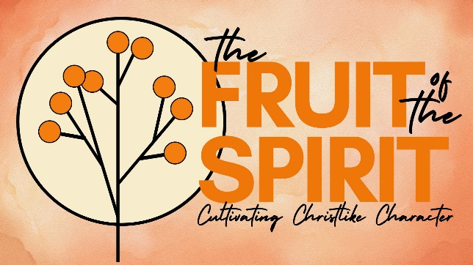
PEACE
Galatians 5:22-23,
John 14:25-27,
Colossians 1:19-23.
- THE SOURCE OF TRUE PEACE

- PEACE FOR YOUR ANXIOUS HEART

- PEACEMAKING IN A COMBAT ZONE


See also: Isaiah 9:1-7; 52:7; 57:21, Colossians 3:15, Ephesians 2:14-17, John 16:33,
Philippians 4:7, James 3:13-18, Romans 12:18.
Discover more (videos, books, articles, songs): visit considerjesus.au

