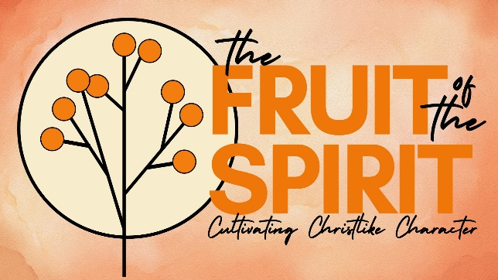
JOY
Galatians 5:22-23
John 15:8-11; 16:20-24

- MAN OF SORROWS | LORD OF JOY

- (RE)DISCOVERING GOSPEL JOY

- REJOICE IN THE LORD!



See also: Nehemiah 8:10, Habakkuk 3:17-18, Psalm 30:5, Luke 10:22-24, Luke 15, Galatians 4:15, Philippians 2:14; 4:4.
More to discover (videos, books, articles, songs): visit considerjesus.au

