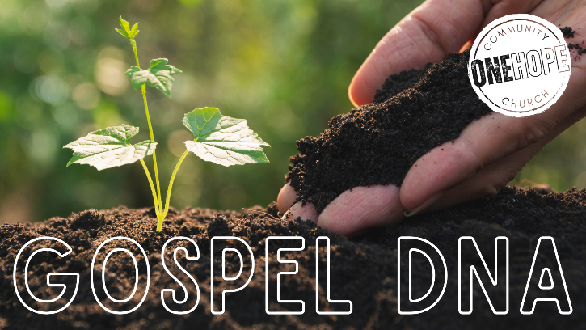
Gospel
Giving
Deuteronomy 26:1-11
2 Corinthians 8-9 (ESV)

- Getting Going with Giving [Firstfruits]

- Grace Guided Generosity

- Giving Gladly for God’s Glory


See also: Deuteronomy 26:1-11, Proverbs 3:9, Jeremiah 2:3, 1 Corinthians 15:20
2 Corinthians 8:1-9; 9:6-15, Acts 20:35, Romans 12:6-8,
Deuteronomy 15:10-11, 1 Corinthians 16:2.

More to discover (videos, books, articles, songs): visit considerjesus.au

