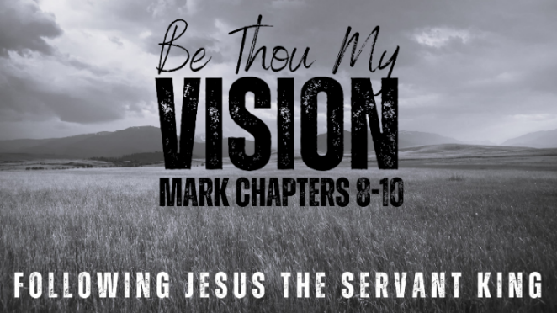
How to Fit a Camel
Through the Eye of a Needle
MARK 10:13-31 (ESV)

- Children, Come to Jesus

- Jesus + Nothing = Everything

- The Impossible Made Possible


See also: Matthew 6:24, 1 Corinthians 1:26-28,
Proverbs 11:28, Romans 3:28, Galatians 3:11,
Ephesians 2:8-9, John 14:6
More to discover (videos, books, articles, songs): visit considerjesus.au

