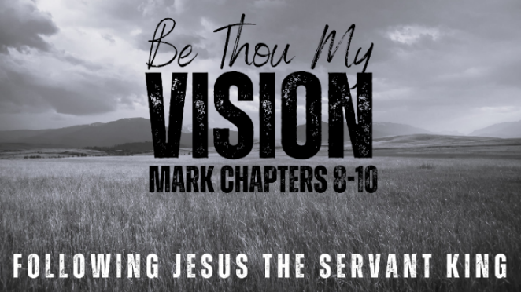
Blind Sight
MARK 10:46-52 (ESV)

- Compared Vision

- “He is Calling You!”

- Salvation Observed

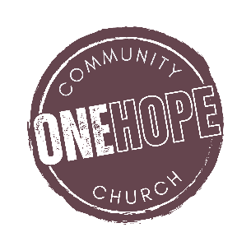
See also: Psalm 51:1, 2 Corinthians 4:4-6, 2 Timothy 1:9-10, Romans 8:30, Isaiah 42:6-7, Ephesians 1, Hebrews 11:1.

More to discover (videos, books, articles, songs): visit considerjesus.au

