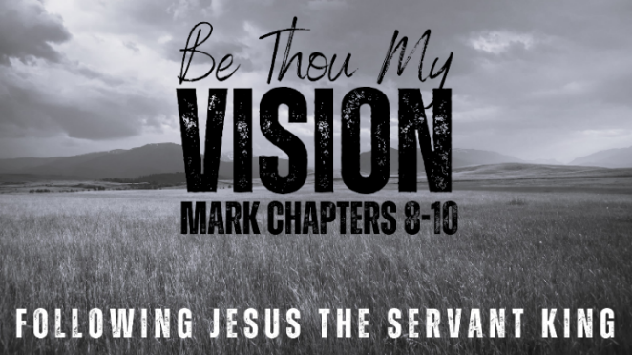
Getting Real
About Marriage
Mark 10:1-12 (ESV)

- The Mess We Make

- The Heart of Marriage

- Honouring God’s Good Design


See also: Genesis 2:18-25, Deuteronomy 24:1, Matthew 19:1-12,
John 4:7-14, Ephesians 5:22-32, Hebrews 13:4, 1 Peter 3:7

More to discover (videos, books, articles, songs): visit considerjesus.au

