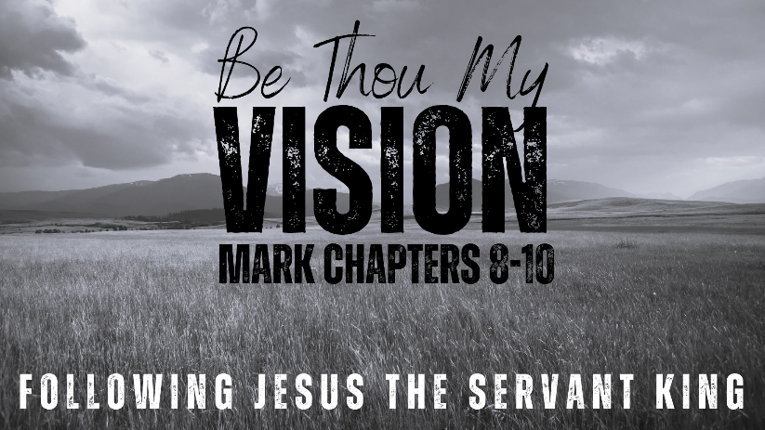
THE
CROSS-SHAPED
LIFE
MARK
8:31-9:1

- The Cross of Christ

- Taking Up Your Cross

- The Way to Glory

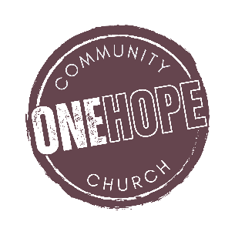

See also: Romans 5:18-19, 2 Corinthians 5:17,
Galatians 6:14, Ephesians 2:1-10; 18-22.
More content (videos, books, articles): considerjesus.au

