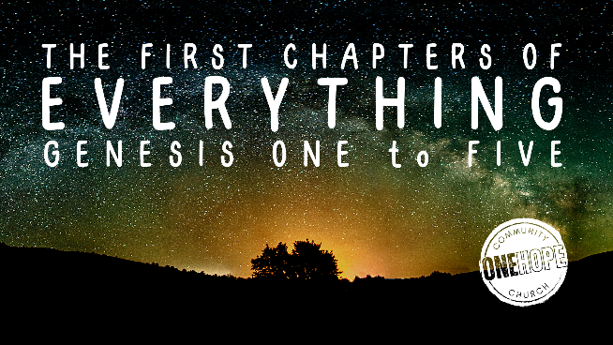
Sunday 4th February 2024
Bible Reading: Genesis 1:1 – 2:3 (ESV)
Sermon: “A Very Good Place to Start”

- Our Amazing Creator

- Exalted Image-Bearers

- A Glorious Future Together

See also:
Psalm 8:3-4; 19:1, 24:1, 139:14-15, John 1:1; 5:17, Romans 1:20-23, 2 Corinthians 4:4, Colossians 1:15-20, Hebrews 1:3, 2 Peter 3, Revelation 14:6-7; 22:1-4.
Gender Ideology by Sharon James (Christian Focus, 2019), Seven Days That Divide the World by John Lennox (HarperCollins, 2021) & considerjesus.au : a website all about Jesus!

